# ReactJS-HOL

Create and Run Your First React App

# Prerequisites (Install Only Once) Step 1: Install Node.js and npm

* + Visit: <https://nodejs.org/en/download/>
  + Download the **LTS version** (recommended for most users)
  + Install it (npm comes bundled with Node.js)

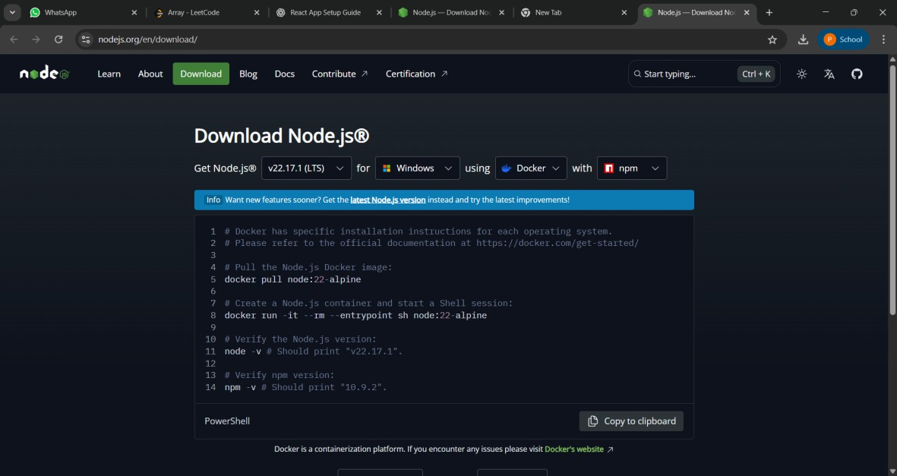

* + To confirm installation, open your terminal/command prompt: node -v

npm -v

# React App Setup

**Step 2: Install create-react-app (Only Once)**

npm install -g create-react-app

# Step 3: Create a new app named myfirstreact

npx create-react-app myfirstreact

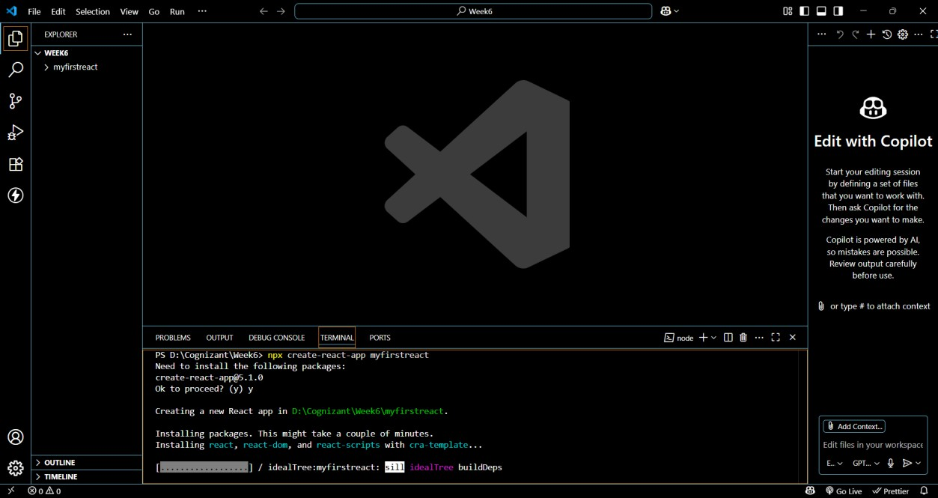

# Step 4: Move into the project folder

cd myfirstreact

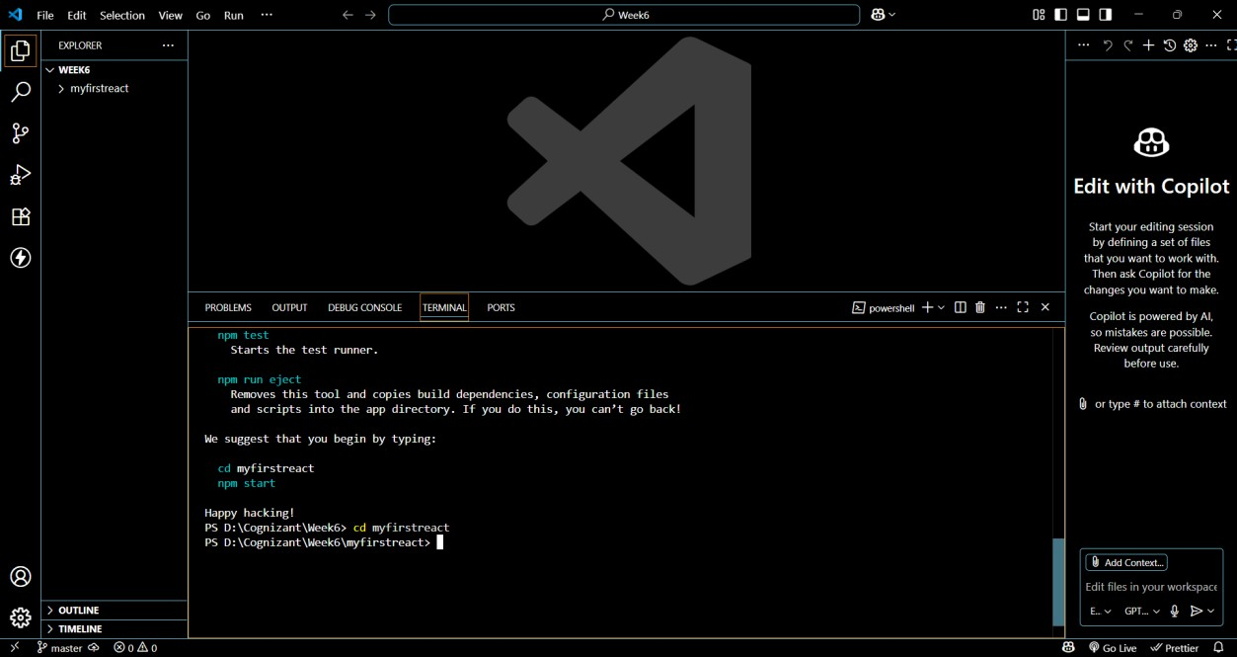

# Modify the App Content Step 5: Open App.js

* + Go to: src > App.js
  + Delete all the existing code
  + Paste this **simple code**: import React from 'react';

function App() { return (

<div>

<h1>Welcome to the first session of React</h1>

</div>

);

}

export default App;

Existing App.js:

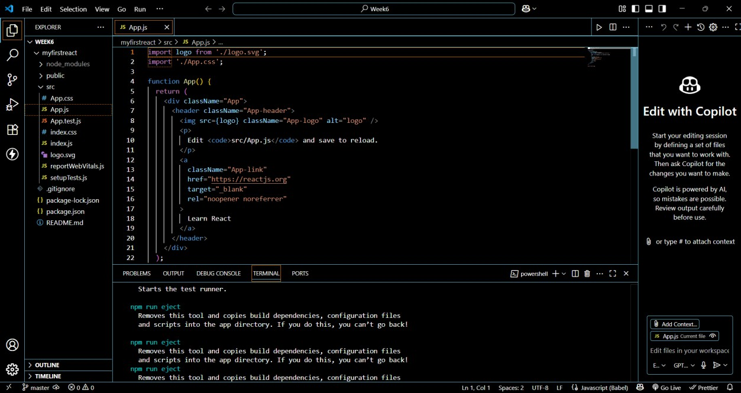

Modified App.js:

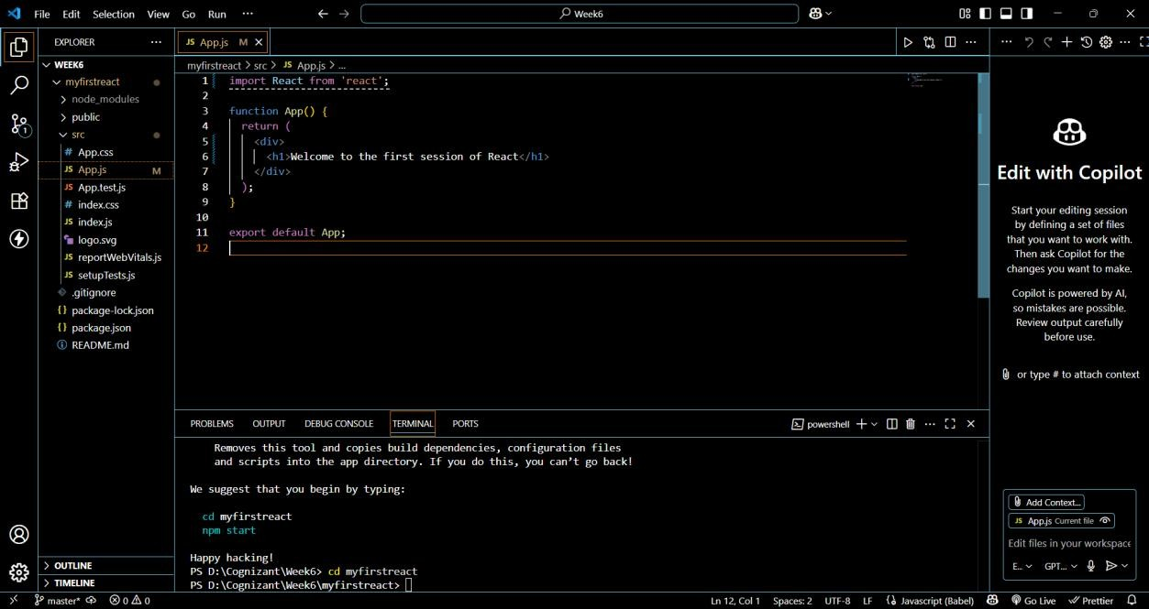

# Run the Application

**Step 7: Start the development server**

In the terminal run:

npm start

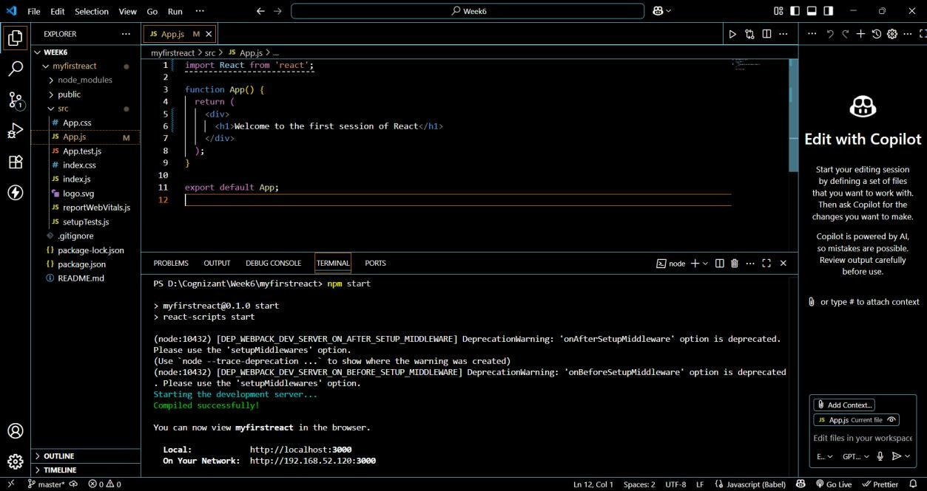

**Step 8: View in Browser** Open your browser and go to: [http://localhost:3000](http://localhost:3000/)

You should see:

Welcome to the first session of React

**Result:**

